Jerry Olds  
1001533643  
IE-4378-001  
9/4/2019

Systems Needed to Support Guidance, Navigation and Control

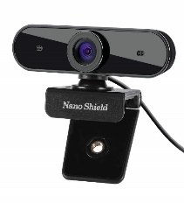Navigation

Sensors

N910 Skype Web Camera Wide Angle

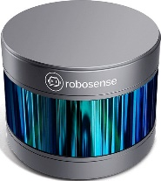

LiDAR sensors

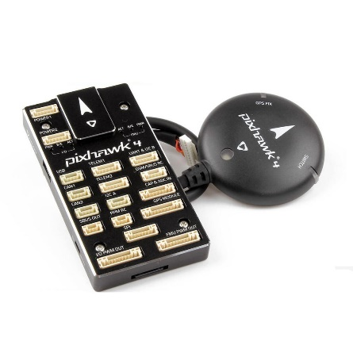

Pixhawk 4 Autopilot and Neo-M8N GPS

Guidance

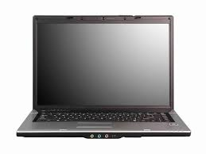

Laptop

 Robot Operating System

Control

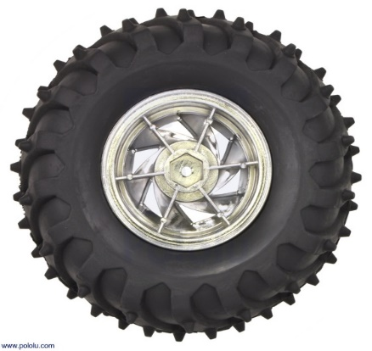

Wheels

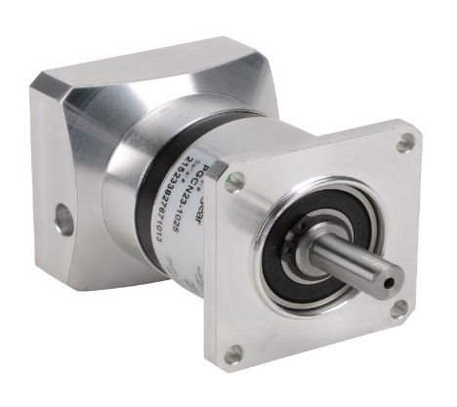

Motors